Introduction 2
Installation 2
Create a new database for Merak Mail 2
Configure Merak Mail Professional to use an ODBC data store 3
Configuring Emerald integration with Merak Mail 3
Trouble Shooting 3

Introduction

We are pleased to provide support for the Merak Mail Pro server. Emerald integrates with Merak by provisioning Emerald account data to Merak Mail through Meraks ODBC interface and default tables. The interface supports synchronization of Domains, Aliases, Accounts and a single Mail forwarding address.

When using Emerald for provisioning you must not use the Merak Administrative user interface to Delete or Add accounts or Domains, these functions MUST be done thru Emerald. To maintain consistency all Additions or Deletions done through the Merak Interface are overwritten. It is acceptable to use the Admin console to make configuration changes to accounts however changes made to the users name, aliases, account expiration, password, and forwarding addresses will be overwritten.

The integration is done by periodically calling a stored procedure from the Emerald task scheduler to make the necessary incremental changes to the Merak database. It takes on average 2.5 minutes (5 max) for account changes to reflect in the Merak Mail system.

Note: Emerald 4.5.8 or later is required for Merak integration.

Installation

Create a new database for Merak Mail
Create a new database for Merak Mail Pro on the same database server as Emerald 4.x. This can be done through Microsoft Enterprise Manager or Sybase Central depending on weather you are using MSSQL Server or Sybase. The name of the Merak Mail database MUST be labled ‘icewarp’ if it is not data synchronization will fail.

Create an ODBC datasource that will be used by Merak Mail to lookup account information. The data source must point at the newly created ‘icewarp’ database. Please DO NOT point this new datasource at your Emerald database. We recommend naming this new datasource ‘merak’

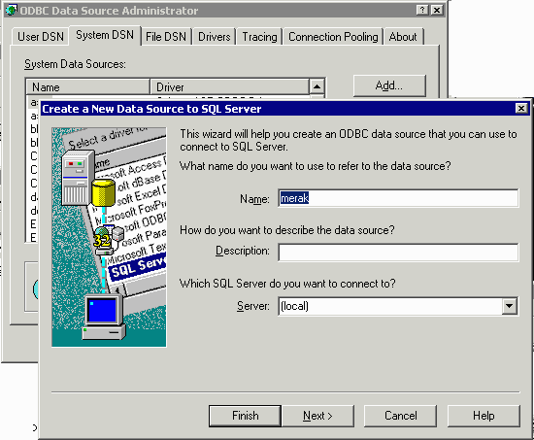

Configure Merak Mail Professional to use an ODBC data store

From the Merak Mail Administrator, select the Professional menu, check the ODBC option from ‘Database Settings’. Click ‘ODBC Settings…’ enter the name of the datasource you created above (‘merak’), click test connection to make sure there is good connectivity between the Mail server and Emerald database. Next click ‘Create Tables’ to create the Merak account database on the SQL Server.

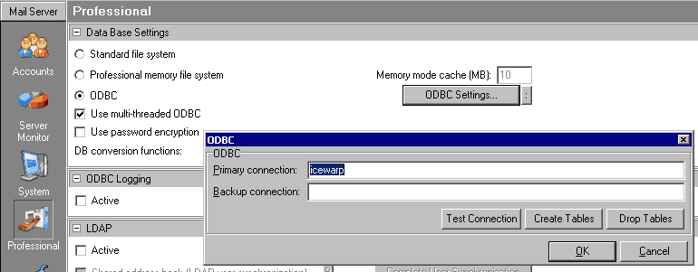

Configuring Emerald integration with Merak Mail
Create a new external system of type Merak Mail and associate the proper service types with the new external system. More information on configuring External Systems and Service types is available in the Emerald Administrators guide.

Run the included merak7.sql script against your Emerald4.x database using a query tool such as Microsoft SQL Query analyzer or ISQL.

Optionally run the query {CALL IceWarpSync(‘full’)} from the Emerald/Admin/Database/SQL Query menu within Emerald. This forces a complete synchronization of account data between Emerald and Merak. If you skip this step Emerald accounts will be synchronized automatically within the next 10-15 minutes.

Trouble Shooting
If you don’t have a Professional menu in the Merak Mail Admin, it is likely you don’t have the professional version of the mail server installed. Please obtain a Professional license from IceWarp before continuing.

If the Merak database is not being updated search the Emerald scheduler log for error messages generated by the Merak sync tasks. This log should show the cause of the problem.

If Merak Mail does not appear as an Export Type in the External Systems menu you first need to upgrade to Emerald version 4.5.8 or higher.

I made a change to an account in Emerald but the change does not appear in the Mail server? It can take up to 5 minutes depending on how often the Merak Mail sync is scheduled to run.

